

# Draw It or Lose It

# **CS 230 Project Software Design Template**

Version 3.0

## Table of Contents

**CS 230 Project Software Design Template**1

**Table of Contents**2

**Document Revision History**2

**Executive Summary**3

**Design Constraints**3

**System Architecture View**3

**Domain Model**3

**Evaluation**3

**Recommendations**5

## Document Revision History

| Version | Date | Author | Comments |
| --- | --- | --- | --- |
| 1.0 | 20 May 2021 | J.F. Kiddy | Initial document |
| 2.0 | 03 Jun 2021 | J.F. Kiddy | OS evaluation |
| 3.0 | 17 Jun 2021 | J.F. Kiddy | Recomendations |

**Instructions**

Fill in all bracketed information on page one (the cover page), in the Document Revision History table, and below each header. Under each header, remove the bracketed prompt and write your own paragraph response covering the indicated information.

## Executive Summary

With the continual demand for mobile Applications and web-based games, Creative Technology Solutions (CTS) has recently taken on a new client, The Gaming Room. CTS has decided to develop software called Lose It or Draw It and are deployed to different platforms. The Gaming Room will develop a web-based game that serves multiple platforms based on their current game, Draw It or Lose It, which is currently available in an Android app only. The application will render images from a large library of stock drawings as clues rather than a player drawing images on an easel. In developing the Lose It or Draw It game common challenge was that the players were drawing images on an easel to help team members guess the puzzle. This led to the delay and less enjoyment of the game.

## Design Constraints

The design phase is the most important stage when developing any application, and especially when developing web-based software. Things that must be considered are the ESS diagram, UML diagram, and class diagrams, as these entries are elements critical to the software developers so they have a visual awareness of the required software. They also provide the developer with the programming tools required and other important requirements from the customers. These constraints further imply the roles, which better allow for understanding and documenting of the developed software.

## System Architecture View

Please note: There is nothing required here for these projects, but this section serves as a reminder that describing the system and subsystem architecture present in the application, including physical components or tiers, may be required for other projects. A logical topology of the communication and storage aspects is also necessary to understand the overall architecture and should be provided.

## Domain Model

The UML diagram below has seven classes; programDriver, SingletonTester, Entity, GameService, Game, Team, and Player. Entity class is a parent interface where it relates to the four child classes; GameService, Game, Team, and Player. The Game, Team and Player, have "is a" relationship with Entity. That means Game is an Entity, Team is an Entity and Player is an Entity. Game, Team and Player all are inherited from Entity. In UML it can be represented by inheritance. Game, Team and Entity, all 3 have common attributes such as id and name. Therefore, it is defined at Super class Entity.

The relationship between Team and Player is of "has a" relationship. Team has Players. Similarly, Game has Teams and GamesService organize (has) Games. In UML it can be represented by Aggregation. Has-A relationship means that an instance of one class has a reference to an instance of another class. In above diagram, GamesService has reference of Games, Games has reference of Team and Team has reference of Player. One GameService can have multiple Games, Each Game have multiple Teams and Teams comprises of multiple Players.

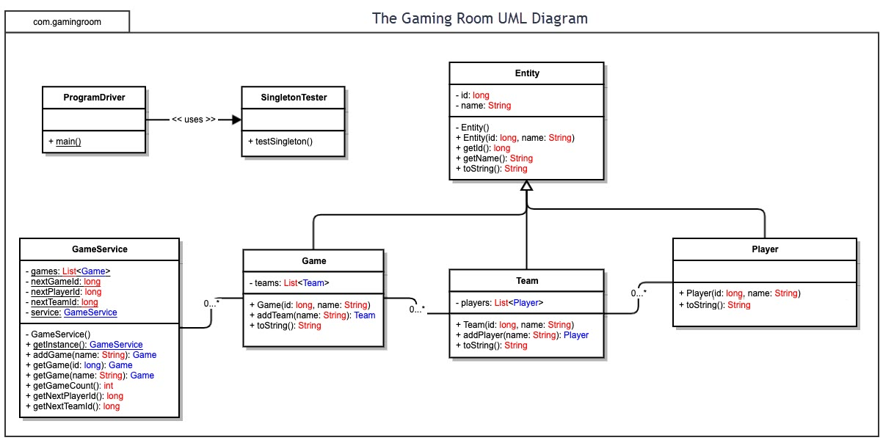

## Evaluation

On the Sever Side there are obviously advantages and drawbacks to a particular OS on their server. While there are many options to choose from but the two primary OS’s that have proven themselves the most reliable are Linux based, examples being Ubuntu, Debian, Fedora or Red Hat to name a few, and Microsoft Windows based server OS. There is a Mac server OS however it is very limited and mainly designed to manage Mac products and allow for a company to use iPads instead of traditional laptops or desktops. For this document on the application for The Gaming Room’s server set up, we will omit the macOS Server from this section.

Starting with a Linux based server OS, there are sever benefits to using this particular OS. Firstly, and probably most crucially the effect of The Gaming Room’s bottom line, is Open-Source software and free. However, despite being relatively secure, but not as secure as Windows, it lacks direct customer support should any issues arise. On the Microsoft side, there is cost associated with their server OS, the basic version costing in excess of $500 and up to just over $6100 depending on features and implementation. Yet with the cost comes a more secure OS and a dedicated support service. Generally, a computer app would be the most beneficial to The Game Room as it relies more on the user’s equipment to pay the game, unfortunately they have to meet minimum hardware and software requirements

Transitioning to the Client Side of the there are a plethora of OS’s that customers could be using which in turn means various software configurations and programing languages need to be accounted for and ensure proper integration and compatibility with the server software. Fortunately, the three most popular OS’s typically run specific software and use their preferred programming language. With Windows typically the Development Tool/IDE: Visual Studio and for their Programming Language: Visual Basic. (By default) For Macs’ OS they us the Development Tool/IDE: XCode and Programming Language: Swift. (Or possibly Objective C) And for Linux the most popular Development Tool/IDE: Eclipse and the Programming Language: C. (By default)

An alternate option to create Web Based application which runs on the user’s browser and on a server from The Game Room. Now dealing with the browsers default technology, it is consisting of HTML, CSS or JAVASCRIPT while the one running on the server is supported by server-side languages such as PHP. And an added perk of the web-based application is rapid updates by the developer yet this will require more resources from The Game Rooms servers then the user’s computer and relying more on the Internet connection to the server, which will vary depending on various factors such as load, weather, bandwidth and network capabilities on the server.

Lastly Mobile App’s have the similar constraints and benefits with the Web Based App however, according to GSMA real-time intelligence data 5.13 billion (66.5%) of the world’s population owns a mobile device, with 2.71 billion (35.1%) owning smart phones, The Gaming Room could reach their largest audience, especially seeing how many people are increasingly not without their smart phones. Also, with only two major mobile OS’s the app production would be easier to manage and produce. iOS uses the same Development Tool/IDE and Programming Language as the macOS. Android’s Development Tool/IDE: Android Studio (By default) and the Programming Language: Java or Kotlin. And with both OS’s having app development software readily available the app creation, while not free would be significantly less than developing a computer application, with no real significant drawbacks.

| **Development Requirements** | **Mac** | **Linux** | **Windows** | **Mobile Devices** |
| --- | --- | --- | --- | --- |
| **Server Side** | **Characteristics:**  Popular web hosting  **Advantages:**  Various options for different web hosting requirements  **Disadvantages:**  It is less preferred for web hosting services | **Characteristics:**  Most secure  **Advantages:**  It is the most preferred choice for web hosting services  **Disadvantages:**  It is more difficult to find application to support the web hosting | **Characteristics:**  Is the most dominant  **Advantages:**  Less load time, high comfort due to wide usage  **Disadvantages:**  Most virus susceptibility | Characteristics:  High portability  **Advantages:**  Has a wider reach, and is cost effective    **Disadvantages:**  Various mobile device brands and  various security requirements |
| **Client Side** | High expertise required to develop software for Mac clients.  It is expensive as the clients are charged monthly.  Much time is required to access the software | Requires high expertise as few applications are available. It is expensive as it’s less popular. Less loading time. | It requires a high expertise as it has high resource requirements.  It is expensive as more resources are required. Less loading time. | It is common and therefore, it has high technical support for the clients. It is cost-effective. It takes less time to load a page |
| **Development Tools** | PHP programming language,  JavaScript | PHP programming language | Java programming,  HTML/CSS  Netbeans | Android Studio, Android programming, iOS Software Development Kit (SDK) |

## Recommendations

Analyze the characteristics of and techniques specific to various systems architectures and make a recommendation to The Gaming Room. Specifically, address the following:

1. **Operating Platform**: We know that all the games on console platforms, PC and mobile, have their own characteristics which have their advantages and their disadvantages. The Windows Operating platform is the recommend environment as it is a common in developing web-based software and also find it relatively the easiest to manage as more people are familiar with the Windows OS while the learning curve to install and manage a Linux server is much steeper. You also have the added support of a dedicated technical support team should issues arise, regular system updates and security patches. This OS is typically considered a complete solution that is quick and easy setup. It provides remote desktop access to the server and having a graphical user interface, Windows Server OS offers this functionality without command-line programming which is used by Linux. If you use Windows software and services (Office, Outlook, and the like), it makes sense to run them on a native platform. It is suitable for the development of the Lose It or Draw It game.
2. **Operating Systems Architectures**: The Windows operating system designed to work with either multi-processor or uniprocessors, with multi core processors being preferred. With two main components, user model and kernel model, kernel mode has unrestricted access to the system memory and external devices while programs and subsystems in user mode are limited in terms of what system resources they can access. It uses packet-driven I/O to process input/output requests. Also incorporating a type 1 Hypervisor, also known as a virtual machine monitor, is software that creates and runs virtual systems. A hypervisor allows one host computer to support multiple guests by virtually sharing its resources, such as memory and processing power. Hypervisors are also isolated from the attack-prone operating system, making them extremely secure.
3. **Storage Management**: The database management tool built into Widows Server system will work effectively and efficiently. However, the better option would be the use of cloud storage, and there are plenty of options. Due to its high compatibility, data synchronization, security and multiple users this storage system is extremely adaptable to The Game Room’s, Draw It or Lose and is extremely suitable for the Windows OS. And with Windows Azure, you are again, just like the server OS, having the support of Microsoft’s dedicated support team and with existing Windows licensees you pay a reduced rate for Azure which is makes the pricing of their cloud storage much more attractive in pricing.
4. **Memory Management**: To accommodate the heavy use from software, Windows applies a memory compression technique which will increases the responsiveness of Windows. Another technique is the page file system where Windows will start removing pages of memory out of RAM and store them temporarily on the hard disk when the amount of memory for the software exceeds the RAM available. On 32-bit (x86) architectures, the total addressable memory is 4GB, divided equally into user space and system space. With a 64-bit architecture, the total address space is theoretically 16 exabyte, but for software and hardware architectural reasons, 64-bit Windows only supports 16TB today, split equally between user and system space. So, the 64-bit architecture is obviously the way to go with a game that has the potential to require a large amount of memory for moving the various pictures in the game.
5. **Distributed Systems and Networks**: Using Wi-Fi as the networking infrastructure will help the system to have a minimal footprint and less cost with the lack of having to run network cables. The use of distributed systems, increasing the number of servers, coupled with superior technological gains in hardware will help alleviate any bottle-necks (limits set by a single component with the lowest throughput of all parts of the application execution path) in capacity of an application or a computer system. And distributed networking, much like distributed systems, has benefits to gaming applications with a higher fault tolerance and resource sharing insuring minimal service disruption. However, in this case there are limits to the scalability of the system. Alternatively, the use of cloud computing can provide scalable, high-capacity computing that works similarly to cloud storage and which would minimize the need for multiple costly servers for a distributed system.
6. **Security**: The Game Room must ensure the gamers details are secured, so protection measures will be put into consideration. The encryption of the clients’ particulars will be the basis of security for this application. To achieve proper security, we must accurately identify the data flow and its vulnerable points. This is much easier to accomplish with your own servers, vice cloud servers. Encrypting all data that travels across or is attached to the network (phones, hard drives, servers) before it is saved to storage, whether local or cloud based will help protect not only The Game Room’s data, but also the customers. And encrypting your data before it is sent to the cloud, which encrypts your data before it is stored Critically though, with cloud-based storage, there is a chance of vulnerably as it is transferred over the internet, perhaps keeping absolutely critical and sensitive data on a local server would be best. Due to the high security capabilities of the Windows operating platform, user protection against intruders will be higher and with regular security patches and updates ensure security of the entire system.